Algebra 1: Unit 10, Lesson 3

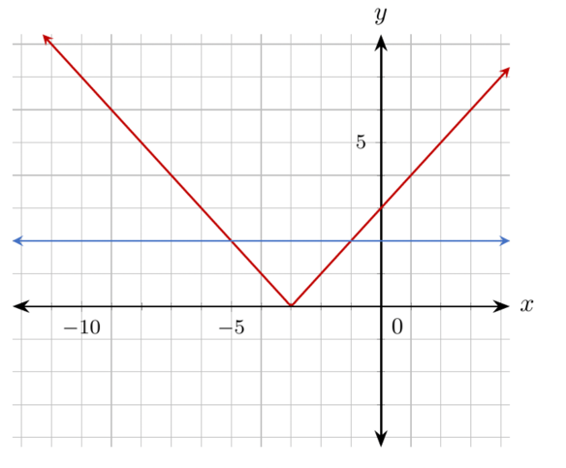
- The graphs of the line $y=2$ and the absolute value function $y=|x+3|$are shown on the coordinate plane.
At what point(s) do the graphs of the line $y=2$ and the absolute value function $y=|x+3|$ intersect?
$(-5,2)$ and $(1,2)$

- An absolute value equation is shown.
$$|x|=8$$
Which of the following values satisfy the equation?
$$-8, 0, 1, 8, 16$$
$-8$ and $8$

- The graph of the function $y=|x|-1$ is shown, along with the lines $y=-2$, $y=-1$, and $y=0$.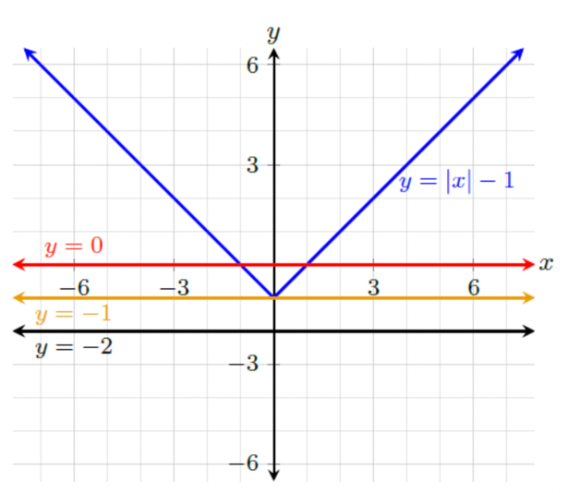
Complete the statements for the function $y=|x|-1$.
There are no values for $x$ such that _______________________.
$$y=-2$$

